Generative AI tools for workplace tasks
Generative AI tools are designed to be creative and collaborative partners. They interact with users conversationally through natural language, making them incredibly versatile for a wide range of tasks like writing, planning, coding, and designing. Some of these tools are standalone applications, while others are seamlessly integrated into the software you use every day. This reading contains an overview of the primary categories of generative AI, key examples, and information about how to strategically integrate them into your work to accomplish more, faster.
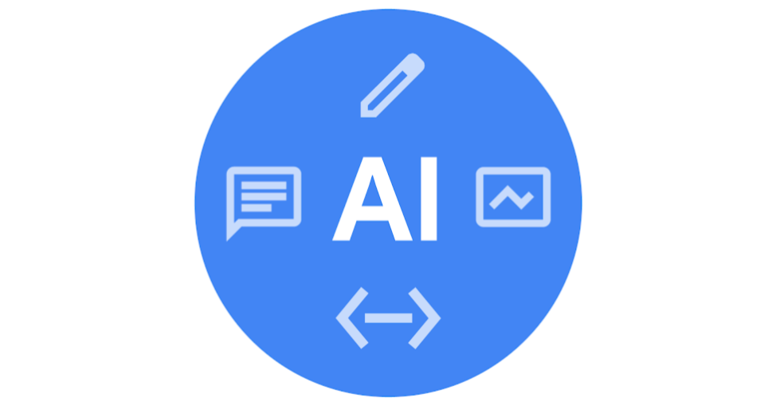

Text and content generative AI tools
These tools are built on Large Language Models (LLMs) that have been trained on vast amounts of text and data. This allows them to understand, summarize, translate, predict, and generate human-like text. They function as versatile assistants for any task involving language, from drafting an email to analyzing complex research papers. Their core strength lies in their ability to process and generate language with nuanced understanding of context, tone, and intent.
Examples include:
- Gemini
- NotebookLM
- Anthropic Claude
- ChatGPT
- Clockwise
- Grammarly
- Jasper
- Microsoft Copilot
- Notion AI
- Zapier

Code-generative AI tools
Often described as an "AI pair programmer," these tools are specialized for software development. They are trained on billions of lines of code from public repositories, enabling them to understand programming languages, frameworks, and common coding patterns. They assist developers by suggesting code completions, generating entire functions from natural language descriptions, identifying and fixing bugs, writing unit tests, and explaining complex code blocks. They integrate directly into Integrated Development Environments (IDEs) to provide real-time assistance.
Examples include:
- Gemini Code Assist
- GitHub Copilot
- Jupyter AI
- Tabnine

Image- and media-generative AI tools
These tools focus on creating and editing multimedia content, including images, video, and audio. They typically use a technology known as diffusion models, which learn to generate novel content from text descriptions (prompts). Users can create photorealistic images, artistic illustrations, marketing materials, and video clips simply by describing what they want to see. These tools are revolutionizing creative workflows by dramatically reducing the time it takes to visualize ideas and produce high-quality media.
Examples include:
- Gemini with Nano Banana
- Asset Studio
- Adobe Firefly
- Canva Magic Design™
- DALL-E
- ElevenLabs
- Midjourney
- Runway

Integrating AI tools into your workflow
The true power of AI is unlocked when it moves from a novelty to a natural part of your daily process. Thoughtful integration can save time, reduce tedious work, and enhance creativity.
Common methods of integration:
- Native features: Many applications you already use are adding built-in AI capabilities. This is the most seamless form of integration, as the AI has context on the work you are already doing within the app.
- Browser extensions: Some tools can be added to your web browser. This allows the AI to assist you across a wide range of web-based applications, from writing emails in Gmail to drafting posts on social media.
- Dedicated applications: Using a standalone tool as a "thinking partner" is a common workflow. You can copy and paste text between your work and the AI tool to brainstorm, summarize, or refine content.
- Automation platforms: For more advanced users, tools can be connected across different apps. These sophisticated platforms allow you to create automated workflows between different apps (e.g., automatically summarizing an email with AI and adding it to a to-do list) without writing any code.
A practical approach to getting started:
- Identify bottlenecks: Pinpoint the most time-consuming or repetitive tasks in your day. Is it writing first drafts? Summarizing meeting notes? Finding bugs in code?
- Start small: Choose one bottleneck and find a single AI tool that addresses it. Focus on mastering that tool for that specific task.
- Build a habit: Make a conscious effort to use your chosen tool whenever you perform that task. The goal is to make it a natural reflex.
- Evaluate and expand: After a week or two, assess the impact. Are you saving time? Is the quality of your work improving? If the integration is successful, look for the next bottleneck and explore how AI can help you there.
A final thought: This list is just a starting point. The world of generative AI is expanding at an incredible pace, with new and more powerful tools emerging continuously. The key is not to become an expert with every tool, but to develop a mindset of curiosity. Take the time to explore tools that suit your specific needs, like Gemini or NotebookLM, and consider how they can augment your skills and support the work of you and those around you.

